粤考办〔2011〕18号

关于中英合作商务管理、金融管理专业（专科）
《商务英语》课程考试试卷结构调整的通知

各有关市自学考试办公室，各有关主考学校：
为了更好地突出专业课程特点，体现新形势下的人才培养目标，推动中英合作商务管理、金融管理专业的发展，剑桥大学考试委员会在充分分析《商务英语》课程（课程代码00796）历年考生群体和考试成绩的基础上，对现行《商务英语》课程的试卷结构进行了调整。根据教育部考试中心《关于中英合作商务管理、金融管理专业（专科）<商务英语>课程考试相关事宜的通知》（教试中心函[2011]87号）精神，从2011年7月考试起《商务英语》课程使用新的试卷结构。现将《商务英语》课程试卷结构调整内容通知如下：
一、考试时间：由原来的165分钟调整为50分钟。2011年7月9日下午《商务英语》课程的考试时间由14:00－16:45调整为14:00－14:50。
二、考核内容：阅读技能。
三、题量及题型：40道客观题。
四、答题方式：在答题卡上作答。考生需携带铅笔（2B）、黑色字迹的签字笔、橡皮等文具参加考试。
《商务英语》课程试卷结构表及样卷详见附件1和2，答题卡式样见附件3。
剑桥大学考试委员会对新的试卷结构进行了严格试测，试测结果显示新的试卷结构体现了该课程的设计目标，充分考查了学生在商务环境下使用英语的能力。新试题注重语言能力的考查，考生并不需要专门针对新试题进行备考。
为了做好考试的实施工作，请各有关市考试机构、各有关主考学校认真落实各项考试要求，及时通知相关考生，保证考试顺利进行。

附件：1.《商务英语》课程试卷结构表
2．《商务英语》课程样卷
3．《商务英语》课程考试答题卡式样

二○一一年六月六日

主题词：自学考试 课程 调整 通知
抄送：各有关县区招生考试办公室，各有关主考学校自学
考试办公室
广东省教育考试院办公室 主动公开 2011年6月7日印发
附件1：
《商务英语》课程试卷结构表

部分 | 题号 | 为考生提供的信息 | 指导语语言 | 考查要点 | 题型 | 分值 | 考试时间  （分钟）
一 | 1—5 | 5个简短的通知或标识 | 英语 | 理解主旨要义和详细信息；词汇 | 多项选择题（三选一） | 每小题2.5分，满分100分 | 50分钟（含答题卡转涂时间）
二 | 6—10 | 5个不完整的会话 | 英语 | 理解会话内容并指出恰当的回答 | 多项选择题（三选一） | 每小题2.5分，满分100分 | 50分钟（含答题卡转涂时间）
三 | 11—15 | 5个相关的句子 | 英语 | 词汇、结构 | 多项选择题（三选一） | 每小题2.5分，满分100分 | 50分钟（含答题卡转涂时间）
四 | 16—20 | 5段材料，如：简短的电子邮件、备忘录、电话记录、便条、通知、标识、广告、新闻简报等 | 英语 | 理解主旨要义和详细信息；词汇 | 多项选择题（三选一） | 每小题2.5分，满分100分 | 50分钟（含答题卡转涂时间）
五 | 21—28 | 1篇事实性段落，摘自百科全书、报纸、杂志等 | 英语 | 语法、词汇、结构 | 完形填空（三选一） | 每小题2.5分，满分100分 | 50分钟（含答题卡转涂时间）
六 | 29—35 | 1篇材料，摘自报纸、杂志等 | 英语 | 理解主旨要义和详细信息 | 判断正误题 | 每小题2.5分，满分100分 | 50分钟（含答题卡转涂时间）
七 | 36—40 | 1篇材料，如：通知、标识、宣传页、目录、广告、网页、计划书等 | 英语 | 理解主旨要义和详细信息；词汇 | 选择搭配题 | 每小题2.5分，满分100分 | 50分钟（含答题卡转涂时间）

附件2：
《商务英语》课程样卷

考试时间：50分钟

中英合作商务管理专业、金融管理专业（专科）合作课程考试
《商务英语》
课程代码：00796

姓名：_________________ 准考证号：__________________

考生注意事项
- 严格遵守考场规则，考生得到监考人员指令后方可开始答题。
- 答题前考生须将自己的姓名和准考证号写在试卷上。
- 请用黑色字迹签字笔填写答题卡上“考生姓名”、“考点名称”、“考场号”、“座位号”、“准考证号”及“课程代码”，并将“准考证号”及“课程代码”对应的信息点使用2B铅笔涂黑。
- 所有答案须填涂在答题卡上，在试卷上作答无效。填涂答案时，用2B铅笔把答题卡上对应题目的答案标号涂黑。如需改动，用橡皮擦干净后再填涂。
- 考试结束后将试卷和答题卡放在桌子上，不得带走。待监考人员收毕清点后，方可离场。

- 任何个人或机构不得保留、复制和出版本试卷，不得以任何形式传播试卷内容。违者必究。

教育部考试中心

Part 1

Questions 1-5

Where can you see these notices?

For Questions 1-5, mark A, B or C on your answer sheet.

Example:
SILENCE!  0 |  | A  B  C | at a meeting  in a library  in a shop  Answer:  0  A B C

1 | DANGER!  DO NOT SWIM HERE | A  B  C | on a hill  in a forest  at a beach

Those with appointments to see the nurse should wait here.
2 |  | A  B  C | in an office  in a hospital  in a bank

The live test contains another three items in Part 1.

Part 2

Questions 6-10

Complete the five conversations.

For Questions 6-10, mark A, B or C on your answer sheet.

Example: 0
A New York


Where do you come from?
B School
C Home

0
A B C

Answer:

6 | We're from London. | A  B  C | Not at all.  Yes, please.  How interesting.

7 | I hate getting up early. | A  B  C | You are, too.  I do, too.  It can, too.

The live test contains another three items in Part 2.

Part 3

Questions 11-15

Read the sentences about a university student.
Choose the best word (A, B or C) for each space.

For Questions 11-15, mark A, B or C on your answer sheet.

Example:

0 | Sarah Packer . . . . . . . . . . to university for the first time on Monday.
0  A B C | A | arrived | B | went | C | was  Answer:

11 | Sarah is doing a four-year . . . . . . . . . . in Business Studies.
 | A | class | B | lesson | C | course
12 | The university secretary was there to . . . . . . . . . . all the new students.
 | A | invite | B | speak | C | welcome

The live test contains another three items in Part 3.

Part 4

Questions 16-20

Look at the messages or notices below.
Choose the best option (A, B or C) to answer each question.

For Questions 16-20, mark A, B or C on your answer sheet.
Example:

Telephone message
Bill Ryan caught 9.30 flight – due here 11.30 now, not 12.30.
 | When does Bill Ryan expect to arrive?
A | 9.30
B | 11.30
C | 12.30
Answer:

0
A B C

————————————————————————————————————

16 | PLEASE NOTE THAT DUE TO HIGHER FUEL COSTS, CHARGES FOR OUR EXPRESS DELIVERY SERVICE HAVE NOW INCREASED.
 | This service will cost more because
 | A | petrol prices have gone up.
 | B | the delivery of goods is taking longer.
 | C | motorbikes are more expensive to buy.
17 | ANNIVERSARY EVENT: 6 AUGUST  Brickworks Ltd invites employees and their families to an evening entertainment in Weston Park.
 | A | Brickworks Ltd is celebrating its sixth anniversary in Weston Park.
 | B | Employees will entertain Brickworks’ guests in Weston Park in August.
 | C | Staff can take their families to Brickworks’ evening entertainment.
The live test contains three more items in Part 4.

Part 5

Questions 21-28

Read the article about farming.
Choose the best word (A, B or C) for each space.

For Questions 21-28, mark A, B or C on your answer sheet.
___________________________________________________________________

The History of Farming

Before people started farming, they went to the forest to look (0) ………… plants or fruit they could eat. This meant that people (21) ………… moving all the time to find food. But about 12,000 years ago, in the Middle East, people (22) ………… to grow food. These people were the first farmers. Farming made (23) ………… possible for people to stay in (24) ………… place and slowly their villages got bigger.

Some people in the villages became free to do other work, like making clothes, (25) ………… the farmers could grow food for everyone. Unfortunately, farming was difficult when the weather was bad and then some people did not get (26) ………… food to eat.

Today, farmers (27) ………… grow more food and it travels thousands of kilometres from where it (28) ………… grown to our homes.

Example:

0
A B C

0 A at B on C for Answer:
___________________________________________________________________

21 A was B been C were

22 A began B begin C begun

23 A this B it C them

24 A one B the C other

25 A but B or C because

26 A enough B all C many

27 A need B can C have

28 A be B being C is

Part 6

Questions 29-35

Read the article about a young girl who plays the violin.

Are sentences 29-35 ‘Right’ (A) or ‘Wrong’ (B)?
If there is not enough information to answer ‘Right’ (A) or ‘Wrong’ (B), choose ‘Doesn’t say’ (C).

For questions 29-35, mark A, B or C on your answer sheet.
___________________________________________________________________

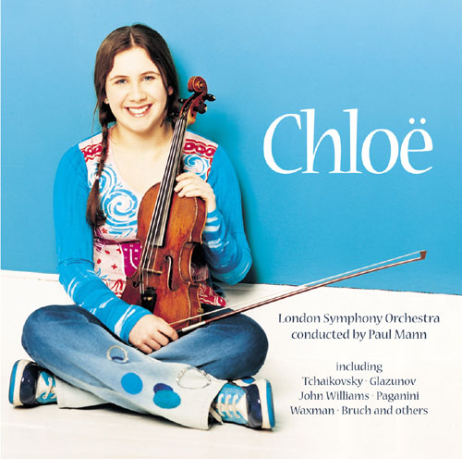
Chloë Hanslip

Chloë was born in England. Her father works with computers and her mother teaches dance. Chloë began playing the violin when she was two. Her parents bought her a special violin which was small enough for her to use, and, even at this age, she could play without help. Her sister Virginia, who was nineteen at the time, played the piano and after Chloë heard her play something, she tried to play it on her violin. From the age of four, she played at a number of concerts in Britain and America and in 1999 she was a child violinist in the Hollywood film Onegin.

Many teachers offered to give Chloë lessons but when she was seven she met Professor Zakhar Bron. She was certain from the beginning that he was the right teacher for her. His work takes him around the world and each year Chloë flies thousands of kilometres to get to his classes.

Chloë was only fourteen when she made her first CD, but she says she is just like any other teenager. ‘I have lots of friends and I love pop music. Getting better on the violin is important, but I also make sure I have time for other things.’

Example:
 |  | 0 |  | Chloë’s mother gives dance classes.
 |  | 0  A B C |  | A | Right |  |  | B | Wrong |  |  | C | Doesn’t say  Answer:
 |  | 29 |  | Chloë’s first violin was the same size as other violins.
 |  |  |  | A | Right |  |  | B | Wrong |  |  | C | Doesn’t say
 |  | 30 |  | To start with, Chloë practised the same music as her sister.
 |  |  |  | A | Right |  |  | B | Wrong |  |  | C | Doesn’t say
 |  | 31 |  | Chloë prefers playing concerts in America to playing in Britain.
 |  |  |  | A | Right |  |  | B | Wrong |  |  | C | Doesn’t say
 |  | 32 |  | When Chloë first met Zakhar Bron, she knew she wanted to study with him.
 |  |  |  | A | Right |  |  | B | Wrong |  |  | C | Doesn’t say
 |  | 33 |  | Chloë travels to other countries for her lessons with Zakhar Bron.
 |  |  |  | A | Right |  |  | B | Wrong |  |  | C | Doesn’t say
 |  | 34 |  | Chloë thinks she has a different life from other people her age.
 |  |  |  | A | Right |  |  | B | Wrong |  |  | C | Doesn’t say
 |  | 35 |  | Chloë plays pop music on the violin for her friends.
 |  |  |  | A | Right |  |  | B | Wrong |  |  | C | Doesn’t say

Part 7

Questions 36-40

Look at the notice below. It shows a list of stands at a Trade Fair.
Decide which stand (A-H) each person needs to visit.

For Questions 36-40, mark one letter (A-H) on your answer sheet.
Do not use any letter more than once.
TRADE FAIR STANDS
A | CIP System: Internal Telephone Systems
B | Bertix Plc: Top-of-the-Range laptops and notebook computers
C | Aurora Ltd: Hands-Free Mobile Phones for Vehicles
D | FastCo Ltd: Distribution Services by road, rail and sea
E | Tops Recruitment Agency: Specialists in Management
F | HTML Ltd: Website Marketing and Internet Advertising
G | Journey.Com: Travel Agency for the Business Executive
H | FTA: Finance for Training

36 | Sally Green imports computer hardware and needs a company to transport it from the port to her chain of stores.
37 | In order to study for an advanced business qualification, Paul White has to take a year off work without pay, and is looking for funding.
38 | John Brown is buying new vans for his service engineers and wants to be able to contact them at any time.
39 | When travelling on business, Ben Smith needs to be able to write letters, send  emails and analyse data.
40 | Sophie Jones wants professional help in finding senior staff for her computer software company.

附件3：
《商务英语》课程考试答题卡式样
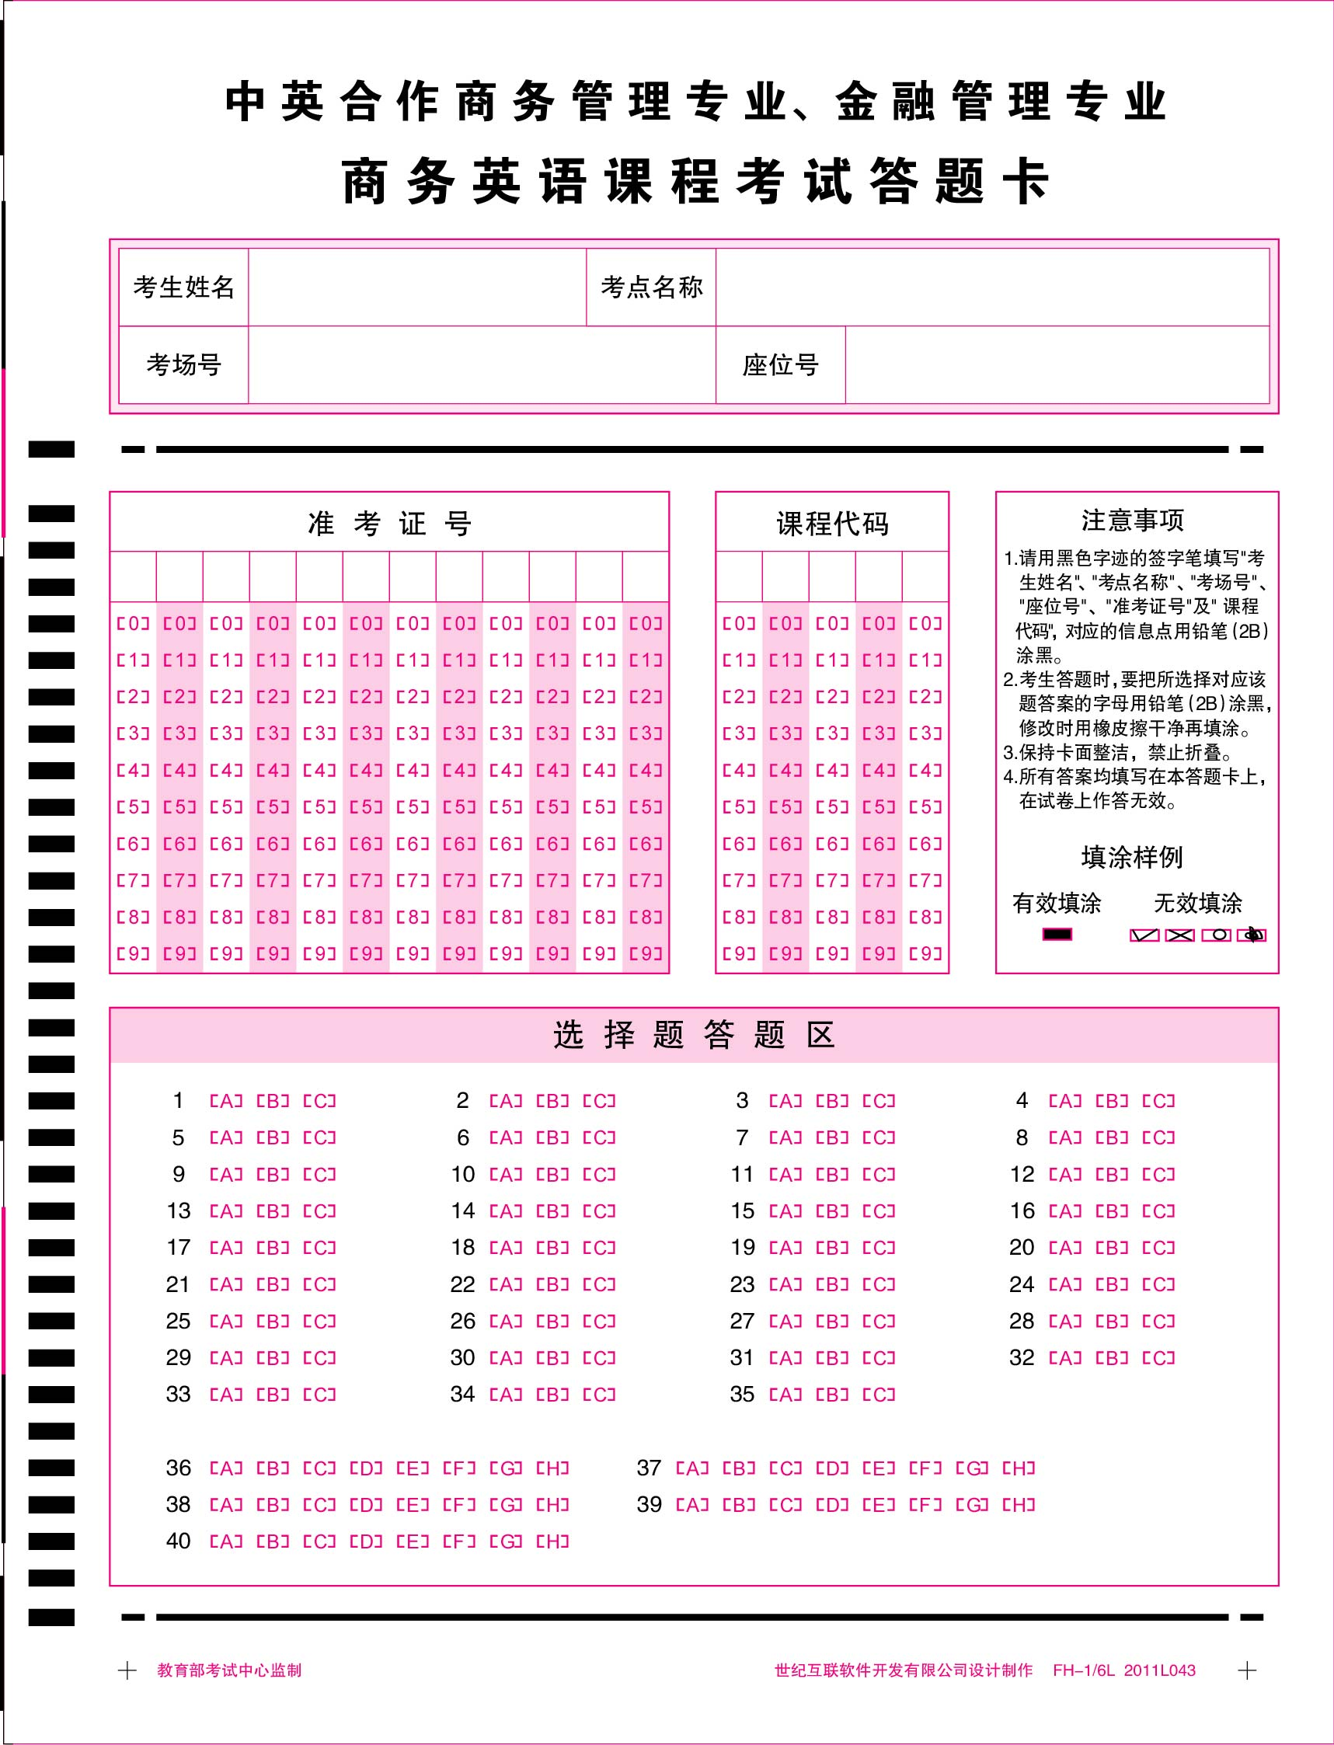

注：尺寸为145mm×190mm

